ADHD Symptoms Among University Students in Egypt
Figures, statistics, tables and charts extracted from the article
El-Farargy SH, Fawzy AM, Elgammal AS, et al. Prevalence of attention-deficit/hyperactivity disorder symptoms and associated factors among university students in Egypt: a cross-sectional study. Scientific Reports 2026;16:26653. doi:10.1038/s41598-026-63835-y. PMC13507199. Licence CC BY 4.0.
How to read this file: tables are transcribed from the article as printed, and the charts are drawn from those tables. Charts marked "calculated" use the table counts (positive / total) and are not printed in the article. Odds ratios here are unadjusted for Tables 1 and 2 and adjusted for Table 4. The tables were read from the article page text, so check each number against the original before citing it.

1. Key statistics
Measure | Value
Sample and response
Responses collected / removed / analysed | 3,136 / 753 / 2,383
Response rate | 76.0%
Minimum required sample | 2,388 (assumed prevalence 2.66%, margin 1%, population 3,495,100)
Pilot sample (excluded) | n = 69; Cronbach alpha 0.85
ASRS validation | Sensitivity 68.7-100%, specificity 83.3-99.5%
Main result
Screening-positive prevalence | 37.9% (95% CI 36.0-39.9%); 904 positive, 1,479 negative
Prior ADHD diagnosis | 3.9% (n = 93)
Sample profile
Female / aged 18-24 / mean age | 65% / 97% / 21 (SD 2)
Medical-related colleges / public universities | 74% / 85%
Delta region | 36%
Obese / mean BMI | 12% / 25.0 (SD 4.4)
Sleep: mean / sleep disorders | 7.28 h (SD 1.66) / 44%
Social media: median | 4 h (IQR 3-6)
Childhood trauma / prior mental health diagnosis | 58% / 15%
Odds ratios quoted in the abstract
Obesity | 2.09 (1.14-3.95)
Smoking | 1.93 (1.25-3.01)
Sleep disorders | 2.12 (1.77-2.55)
Childhood trauma | 1.42 (1.18-1.71)
Mental health history | 1.71 (1.34-2.18)
Regular exercise | 0.55 (0.44-0.70)
Comparison figures cited in the discussion
Egyptian medical students (cited study) | About 11% screened positive
Saudi Arabia / Jordan / Malaysia | 40.3% / 24.8% / 15.8%
US / South Korea | 20% (68/335) / 1.1%
Norway | 2.4% and 1.1% (61,129 of 5,490,678)
Netherlands | 1.0% and 2.5%
Community sample / Wisconsin students / Kessler 2006 | 4.7% (n = 720) / 4% (n = 448) / 4.4% (n = 154)
Ten-country range | 1.2-7.3% (mean 3.4%, high-income 4.2%)
University samples (Italy n = 197, US n = 799, New Zealand n = 213) | 0-8.1%
Background figures cited
US children with ADHD | 11.4% (about 1 in 9)
Persistence into adulthood | "Up to 60%" (introduction), "up to 90%" (discussion), also 40-50%
Adult comorbidity | At least one other condition in 80%
Male:female ratio in prior literature | 3:1 and 10:1
Sleep-ADHD OR in other medical-student studies | 2.21 (p < 0.001)

2. Study flow (Figure 1)
Figure 1 is a flowchart of inclusion and exclusion: 3,136 responses received, 753 removed, 2,383 analysed. Figure 2 is a bar chart of screening-positive prevalence by region with 95% CI error bars; the article text gives no per-region values, so it is not redrawn here.

3. Table 1: demographic characteristics
N = 2,383 (negative 1,479; positive 904). Percentages are column percentages. * p<0.05, ** p<0.01, *** p<0.001. "Not legible" means the OR cell in the source repeats other values; the obese OR is taken from the article text.
Variable | Total n (%) | Negative n (%) | Positive n (%) | OR | 95% CI | p
Age
Youth (15-24 years) | 2313 (97) | 1439 (97) | 874 (97) | - | -
Young adults (25-44 years) | 70 (2.9) | 40 (2.7) | 30 (3.3) | 1.23 | 0.76-1.99 | 0.390
Mean (SD) | 21 (2) | 21 (2) | 21 (2)
Median [Q1-Q3] | 21 [19-22] | 21 [19-22] | 20 [19-22]
Sex
Female | 1538 (65) | 919 (62) | 619 (68) | - | -
Male | 845 (35) | 560 (38) | 285 (32) | 0.76** | 0.63-0.90 | 0.002
Nationality
Egyptian | 2321 (97) | 1444 (98) | 877 (97) | - | -
Non-Egyptian | 62 (2.6) | 35 (2.4) | 27 (3.0) | 1.27 | 0.76-2.11 | 0.357
Marital status
Currently married | 83 (3.5) | 52 (3.5) | 31 (3.4) | - | -
Currently not married | 2300 (97) | 1427 (96) | 873 (97) | 1.03 | 0.66-1.63 | 0.911
Family income
Just enough | 1423 (60) | 877 (59) | 546 (60) | - | -
More than enough | 826 (35) | 524 (35) | 302 (33) | 0.93 | 0.77-1.10 | 0.394
Not enough | 134 (5.6) | 78 (5.3) | 56 (6.2) | 1.15 | 0.80-1.65 | 0.437
Residence place
Rural | 1109 (47) | 695 (47) | 414 (46) | - | -
Urban | 1274 (53) | 784 (53) | 490 (54) | 1.05 | 0.89-1.24 | 0.570
Region
Greater Cairo | 524 (22) | 325 (22) | 199 (22) | - | -
Alexandria | 587 (25) | 389 (26) | 198 (22) | 0.83 | 0.65-1.06 | 0.141
Delta | 868 (36) | 518 (35) | 350 (39) | 1.10 | 0.88-1.38 | 0.386
Suez Canal | 154 (6.5) | 92 (6.2) | 62 (6.9) | 1.10 | 0.76-1.59 | 0.609
Upper Egypt | 250 (10) | 155 (10) | 95 (11) | 1.00 | 0.73-1.36 | 0.995
University
Public | 2026 (85) | 1271 (86) | 755 (84) | - | -
Private | 357 (15) | 208 (14) | 149 (16) | 1.21 | 0.96-1.51 | 0.109
College
Medical-related | 1754 (74) | 1066 (72) | 688 (76) | - | -
Not medical-related | 629 (26) | 413 (28) | 216 (24) | 0.81* | 0.67-0.98 | 0.030
BMI
Underweight (< 18.5) | 56 (2.3) | 39 (2.6) | 17 (1.9) | - | -
Normal (18.5 to < 25) | 1289 (54) | 817 (55) | 472 (52) | not legible | 0.75-2.43 | 0.342
Overweight (25 to < 30) | 763 (32) | 479 (32) | 284 (31) | not legible | 0.77-2.51 | 0.305
Obese (>= 30) | 275 (12) | 144 (9.7) | 131 (14) | 2.09 (text) | 1.14-3.95 | 0.019
Mean (SD) | 25.0 (4.4) | 24.7 (4.2) | 25.4 (4.7)
Median [Q1-Q3] | 24.4 [22.0-27.1] | 24.2 [21.8-26.8] | 24.5 [22.2-27.7]

Chart 1a: share screening-positive in each group (calculated)
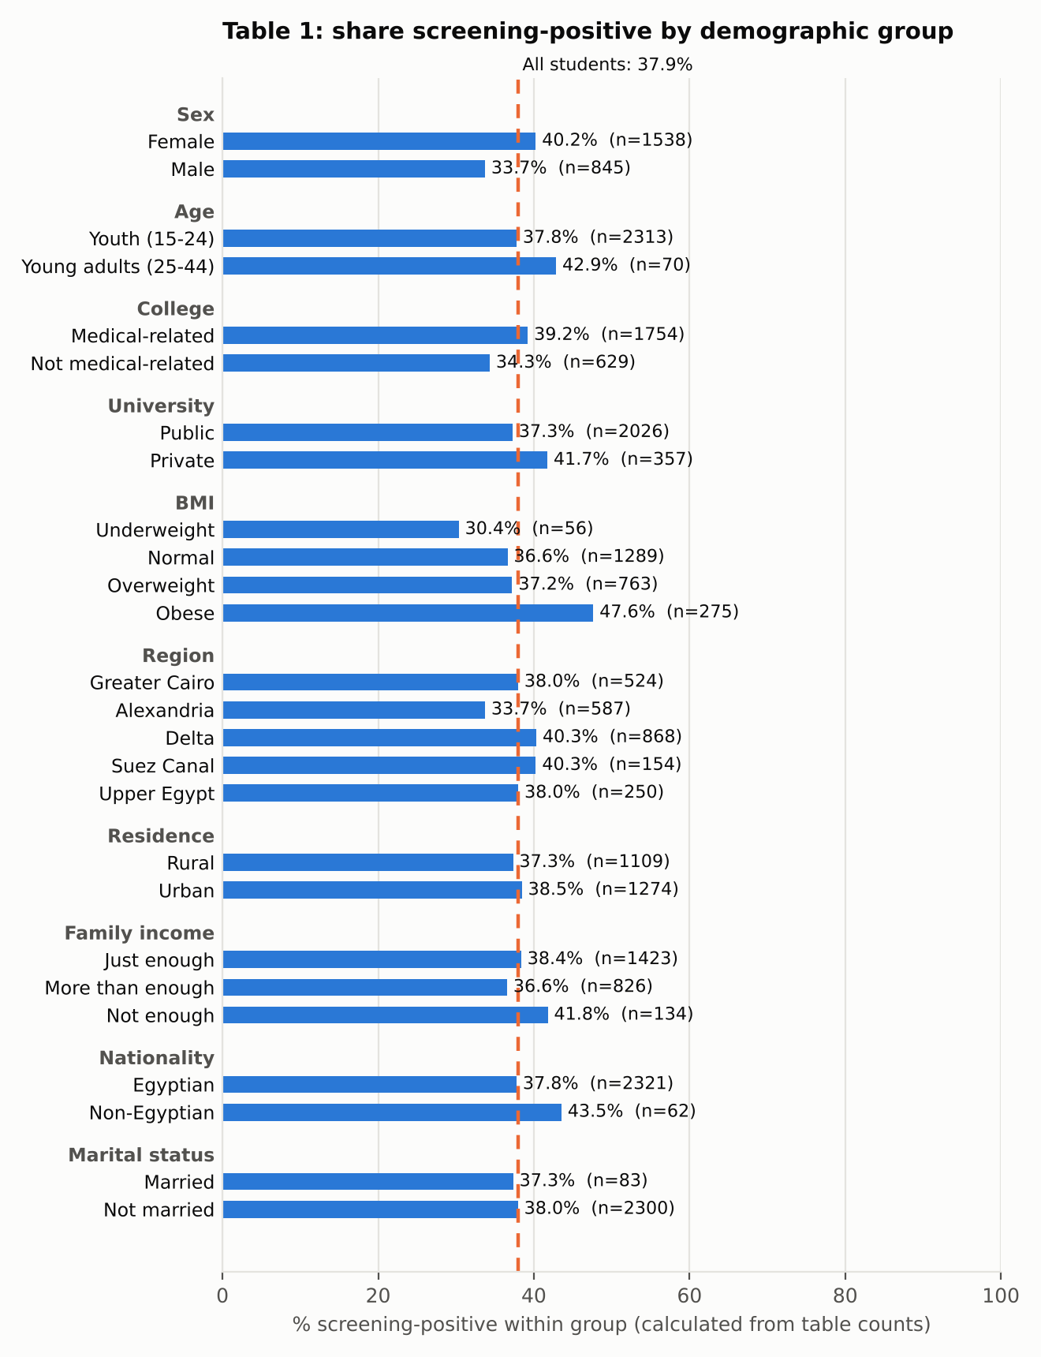

Chart 1b: odds ratios
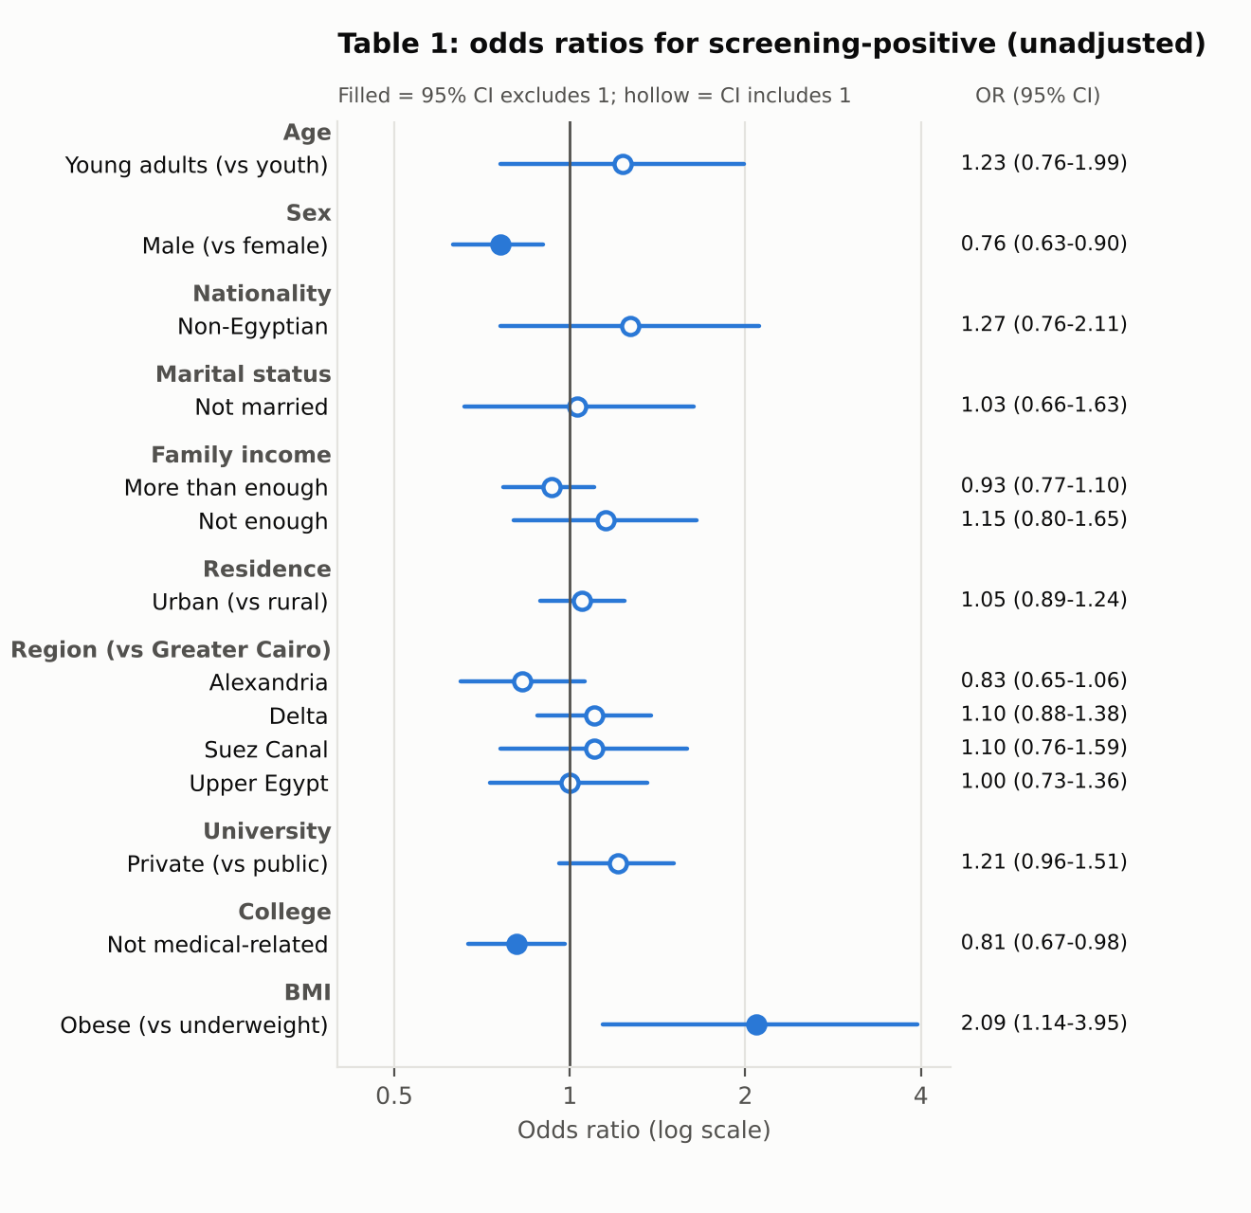
Only male sex (OR 0.76), non-medical college (0.81) and obesity (2.09) have confidence intervals that exclude 1. The article gives no readable OR for normal and overweight BMI, so those are not plotted.

4. Table 2: lifestyle and history
Same layout and significance marks as Table 1. The five rows from chronic illness down are misaligned in the source: the OR column holds the confidence interval and the p-value is blank, so no OR can be plotted for them.
Variable | Total n (%) | Negative n (%) | Positive n (%) | OR | 95% CI | p
Smoking
No | 2299 (96) | 1440 (97) | 859 (95) | - | -
Yes | 84 (3.5) | 39 (2.6) | 45 (5.0) | 1.93** | 1.25-3.01 | 0.003
Regular exercise
No | 1879 (79) | 1111 (75) | 768 (85) | - | -
Yes | 504 (21) | 368 (25) | 136 (15) | 0.53*** | 0.43-0.66 | <0.001
Sleep disorders
No | 1331 (56) | 959 (65) | 372 (41) | - | -
Yes | 1052 (44) | 520 (35) | 532 (59) | 2.64*** | 2.23-3.13 | <0.001
Average daily sleep, last month
6-8 h | 1125 (47) | 735 (50) | 390 (43) | - | -
< 6 h | 785 (33) | 462 (31) | 323 (36) | 1.32** | 1.09-1.59 | 0.004
9-10 h | 404 (17) | 247 (17) | 157 (17) | 1.20 | 0.95-1.51 | 0.132
> 10 h | 69 (2.9) | 35 (2.4) | 34 (3.8) | 1.83* | 1.12-2.99 | 0.015
Mean (SD) | 7.28 (1.66) | 7.30 (1.59) | 7.25 (1.78)
Median [Q1-Q3] | 7.00 [6.00-8.00] | 7.00 [6.00-8.00] | 7.00 [6.00-8.00]
Daily hours on social media
Moderate (2-3 h) | 868 (36) | 552 (37) | 316 (35) | - | -
Low (0-1 h) | 403 (17) | 301 (20) | 102 (11) | 0.59*** | 0.45-0.77 | <0.001
High (4+ h) | 1112 (47) | 626 (42) | 486 (54) | 1.36** | 1.13-1.63 | 0.001
Mean (SD) | 5 (3) | 5 (3) | 5 (3)
Median [Q1-Q3] | 4 [3-6] | 4 [3-6] | 5 [3-7]
Daily hours on devices for other purposes
3-4 h | 711 (30) | 454 (31) | 257 (28) | - | -
0-2 h | 1003 (42) | 648 (44) | 355 (39) | 0.97 | 0.79-1.18 | 0.749
4+ h | 669 (28) | 377 (25) | 292 (32) | 1.37** | 1.10-1.70 | 0.004
Mean (SD) | 5.0 (3.5) | 4.8 (3.5) | 5.3 (3.6)
Median [Q1-Q3] | 4.0 [2.0-7.0] | 4.0 [2.0-7.0] | 5.0 [2.0-8.0]
Childhood trauma or impactful events
No | 1002 (42) | 706 (48) | 296 (33) | - | -
Yes | 1381 (58) | 773 (52) | 608 (67) | 1.88*** | 1.58-2.23 | <0.001
Chronic illness (row misaligned in source)
No | 2131 (89) | 1358 (92) | 773 (86) | - | -
Yes | 252 (11) | 121 (8.2) | 131 (14) | not legible | 1.46-2.47 | blank
Diagnosed mental health condition (row misaligned in source)
No | 2026 (85) | 1318 (89) | 708 (78) | - | -
Yes | 357 (15) | 161 (11) | 196 (22) | not legible | 1.81-2.85 | blank
Family history of ADHD (row misaligned in source)
No | 2164 (91) | 1363 (92) | 801 (89) | - | -
Yes | 219 (9.2) | 116 (7.8) | 103 (11) | not legible | 1.14-2.00 | blank
Regular medication for chronic disease (row misaligned in source)
No | 1935 (81) | 1243 (84) | 692 (77) | - | -
Yes | 448 (19) | 236 (16) | 212 (23) | not legible | 1.31-1.99 | blank
Addictive drugs or illicit stimulants (row misaligned in source)
No | 2347 (98) | 1464 (99) | 883 (98) | - | -
Yes | 36 (1.5) | 15 (1.0) | 21 (2.3) | not legible | 1.20-4.61 | blank

Chart 2a: share screening-positive among students with each factor (calculated)
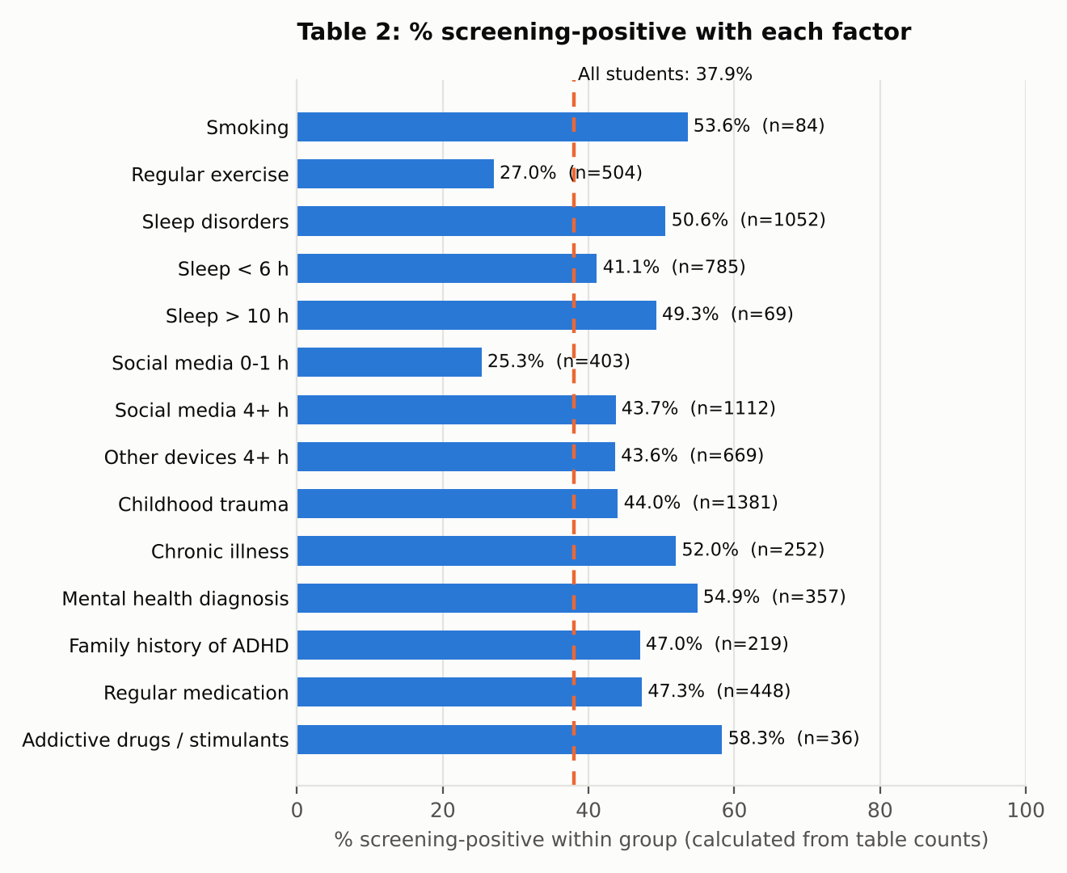

Chart 2b: odds ratios
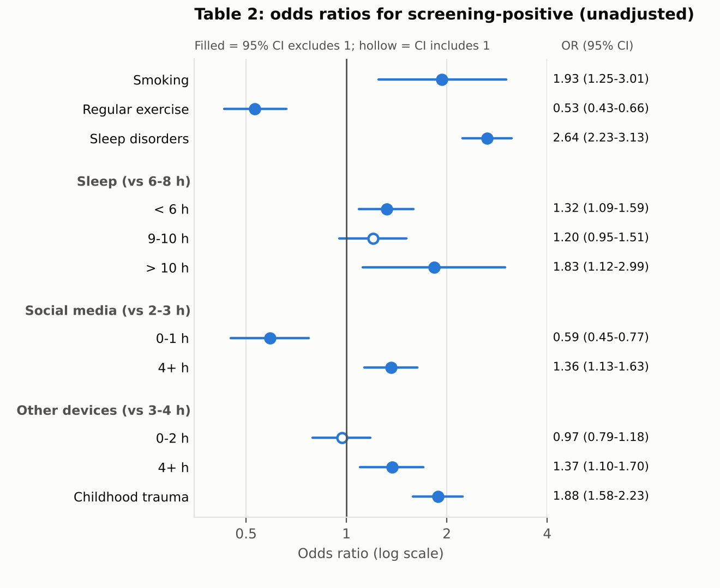
Sleep disorders (OR 2.64), childhood trauma (1.88), smoking (1.93) and more than 10 h sleep (1.83) have the largest ORs. Regular exercise (0.53) and 0-1 h daily social media (0.59) are lower. Note that the article's abstract quotes the adjusted OR for sleep disorders (2.12), while this table shows the unadjusted 2.64.

5. Table 3: ASRS item responses
N = 2,383 per item. Items 1-6 are Part A (screening); 7-18 are Part B. Item wording is paraphrased, not verbatim. The last column (Often + Very often) is calculated.
Item | Never | Rarely | Sometimes | Often | Very often | Often + Very often
1. Difficulty finishing details of projects | 16.5% | 18.5% | 37.2% | 16.8% | 11.0% | 27.8%
2. Difficulty organizing tasks | 12.4% | 23.7% | 35.6% | 17.6% | 10.7% | 28.3%
3. Forgetting appointments | 13.8% | 31.3% | 30.5% | 13.8% | 10.6% | 24.4%
4. Avoiding or delaying complex tasks | 10.3% | 20.5% | 33.3% | 20.8% | 15.1% | 35.9%
5. Fidgeting or squirming when sitting long | 9.4% | 17.1% | 27.4% | 19.9% | 26.1% | 46.0%
6. Feeling overly active or compelled to do things | 19.3% | 26.3% | 31.6% | 13.8% | 8.9% | 22.7%
7. Careless mistakes on boring or difficult tasks | 18.1% | 27.8% | 31.3% | 13.2% | 9.5% | 22.7%
8. Difficulty focusing on repetitive work | 7.1% | 16.1% | 32.4% | 25.6% | 18.9% | 44.5%
9. Trouble concentrating in conversations | 17.5% | 31.1% | 29.2% | 13.3% | 8.9% | 22.2%
10. Losing or misplacing things | 13.1% | 30.0% | 31.2% | 14.5% | 11.2% | 25.7%
11. Easily distracted by noise or activity | 5.9% | 14.7% | 30.5% | 26.9% | 21.9% | 48.8%
12. Leaving seat when expected to stay seated | 28.8% | 32.6% | 24.3% | 8.9% | 5.4% | 14.3%
13. Feeling restless or fidgety | 4.7% | 16.6% | 34.3% | 23.2% | 21.1% | 44.3%
14. Difficulty relaxing in free time | 19.8% | 29.8% | 27.4% | 13.5% | 9.6% | 23.1%
15. Talking excessively in social settings | 12.1% | 25.1% | 32.6% | 17.2% | 13.0% | 30.2%
16. Interrupting others in conversation | 17.1% | 31.3% | 30.7% | 12.9% | 8.0% | 20.9%
17. Trouble waiting my turn | 13.1% | 24.5% | 30.3% | 18.7% | 13.4% | 32.1%
18. Interrupting others while they are busy | 20.9% | 37.6% | 24.4% | 10.4% | 6.8% | 17.2%

Chart 3a: response profile for every item
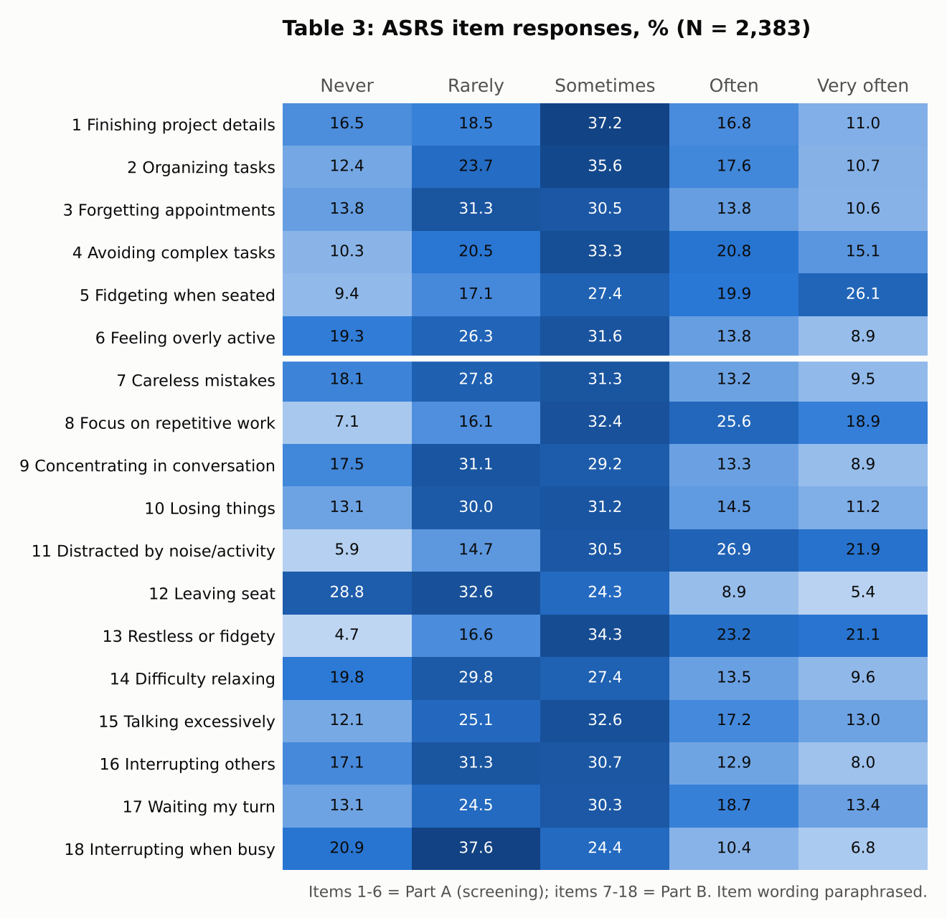

Chart 3b: items ranked by Often + Very often
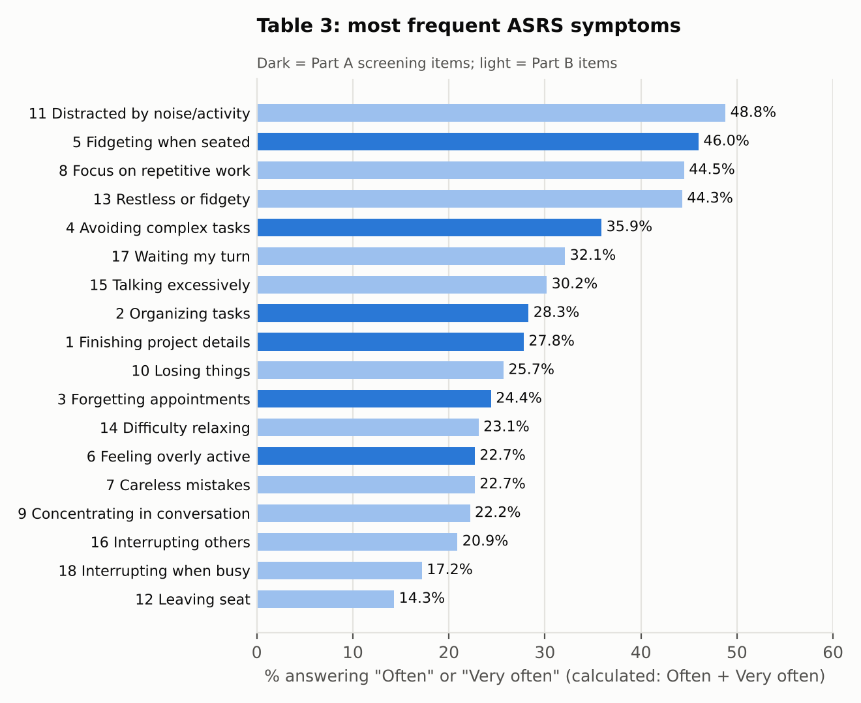
Being easily distracted by noise or activity (48.8%), fidgeting when seated (46.0%), difficulty focusing on repetitive work (44.5%) and feeling restless (44.3%) were the most frequent. Screening-positive means scoring at least 4 on Part A; Part B was not used for the classification.

6. Table 4: multivariable logistic regression
Outcome: ASRS screening-positive. The article labels the estimates "OR"; they come from the multivariable model, so they are adjusted. * p<0.05, ** p<0.01, *** p<0.001.
Variable | Category | Adjusted OR | 95% CI | p
Intercept | - | 0.32*** | 0.25-0.40 | <0.001
Sex | Male (ref: female) | 0.99 | 0.82-1.20 | 0.949
Family history of ADHD | Yes | 1.25 | 0.93-1.69 | 0.136
Diagnosed mental health condition | Yes | 1.71*** | 1.34-2.18 | <0.001
Regular exercise | Yes | 0.55*** | 0.44-0.70 | <0.001
Sleep disorders | Yes | 2.12*** | 1.77-2.55 | <0.001
Average daily sleep (ref: 6-8 h) | < 6 h | 1.04 | 0.85-1.28 | 0.681
 | 9-10 h | 0.96 | 0.74-1.23 | 0.729
 | > 10 h | 1.30 | 0.77-2.18 | 0.330
Social media (ref: 2-3 h) | 0-1 h | 0.62*** | 0.47-0.81 | <0.001
 | 4+ h | 1.26* | 1.04-1.53 | 0.017
Childhood trauma or impactful events | Yes | 1.42*** | 1.18-1.71 | <0.001
Chronic illness | Yes | 1.53** | 1.15-2.02 | 0.003

Chart 4: adjusted odds ratios
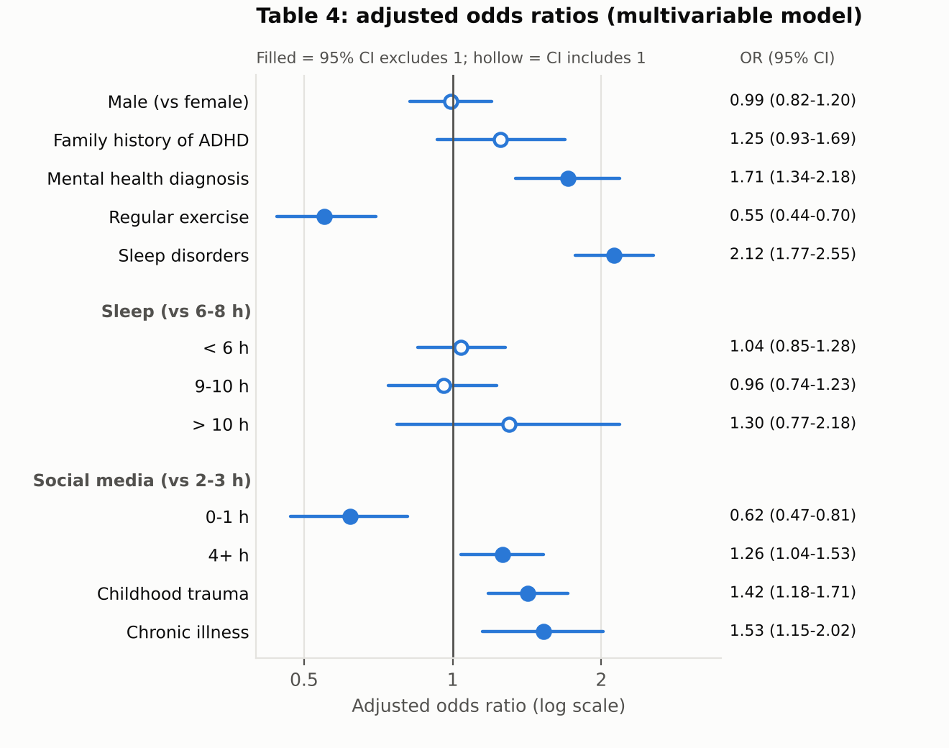
After adjustment, mental health diagnosis (1.71), sleep disorders (2.12), childhood trauma (1.42), chronic illness (1.53) and 4+ h of social media (1.26) stay significantly higher, and regular exercise (0.55) and 0-1 h of social media (0.62) stay lower. Male sex, family history, and sleep duration are not significant. Smoking and obesity, highlighted in the abstract, are not in this final model.

7. Inconsistencies found in the source
Check these before you cite the article:
- The discussion gives 2,689 participants, while the results report 2,383.
- The discussion gives 32.8% male; Table 1 gives 35%.
- The discussion mentions a cutoff of 14 or more, while the methods score at least 4 on Part A.
- The results text contains a placeholder: "[37% or your exact number]".
- Table 1 labels the youth age group "15-24 years", but participants had to be 18 or older.
- The required sample (2,388) is slightly larger than the analysed sample (2,383).
- Five Table 2 rows are misaligned, and the BMI ORs in Table 1 are not legible.
- The authors say results should not be read as diagnostic prevalence, yet 37.9% is the headline figure. It is a screening-positive rate.

